Brazil Day
Thursday 19th May
Main:
Brazilian Style Fried Chicken served with Potato Wedges
Brazilian Style Fried Quorn served with Potato Wedges
Jacket Potato with Cheese, Beans or Tuna (v)
All served with a Vegetable Medley and Fresh Salad
Dessert:
Tropical Fruit Salad and Ice Cream
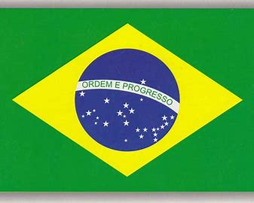
Yoghurt
Fresh Fruit

