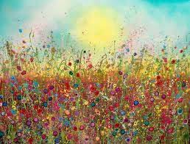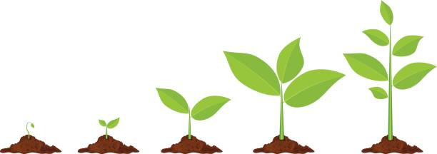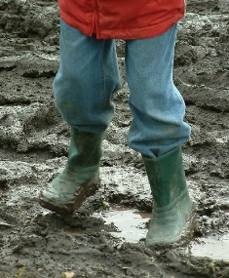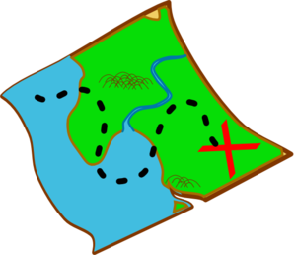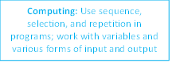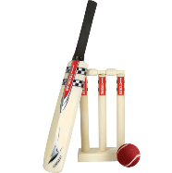

Day

**ENGLISH: How to grow your own lettuce –** To write a set of instructions with a detailed introduction.

.

.

**ENGLISH: Grendel –** To write a wishing-type story with dialogue to show character.

Understand what they are reading by drawing inferences, justifying inferences with evidence. composing and rehearsing sentences orally (including dialogue), progressively building a varied and rich vocabulary and an increasing range of sentence structures.

.

.

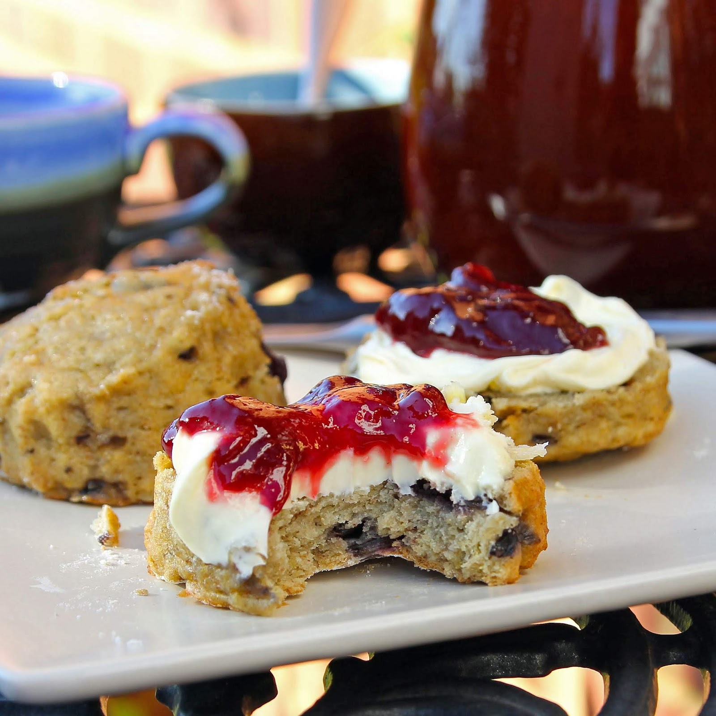

[This Photo](https://www.glutenfreealchemist.com/2018/09/cherry-bakewell-scones-gluten-free.html) by Unknown Author is licensed under [CC BY-NC-ND](https://creativecommons.org/licenses/by-nc-nd/3.0/)

**Design and Technology: English Traditional Food** – Baking Scones – World Explorer Day

**Art:** To improve their mastery

of art and design techniques, including drawing, painting and sculpture with a range of materials [for example, pencil, charcoal, paint, clay] colours.

**FINAL EVENT:**

Map reading/treasure hunt.

To have written a wishing-type story and .



[This Photo](http://cyberontech.blogspot.no/2013/03/touchscreen-laptops-review.html) by Unknown Author is licensed under [CC BY](https://creativecommons.org/licenses/by/3.0/)

**Geography**: Use fieldwork to observe and record the human and physical features in the local area? For example, surveys, drawings and photographs.

**Art:** Create a class canvas in Yvonne Coomber style.



[This Photo](http://pngimg.com/download/25561) by Unknown Author is licensed under [CC BY-NC](https://creativecommons.org/licenses/by-nc/3.0/)



[This Photo](https://www.freeimageslive.co.uk/free_stock_image/art-painting-brushes-jpg) by Unknown Author is licensed under [CC BY](https://creativecommons.org/licenses/by/3.0/)

**Discreet Subjects:**

**Maths :** Y2: Temperature and fractions Y3: Volume and fractions

**Spanish:** Pets and Animals (including colours)

**Music:** Integrated with computing.

**RE:**What kind of world did Jesus want?(UC: GOSPEL)

**PSHE/RSE:**How do we show our feelings? (Y2 Jigsaw)

**Geography:** Use fieldwork to observe, measure, record and present the human and physical features in the local area using a range of methods, including sketch maps, plans and graphs, and digital technologies.

**HOOK: Explore our local area and explore Google Maps.**

Roots, shoots and

muddy boots.

What is special about where we live?

**Art:** Focus on local artist, Yvonne Coomber.

**Science:** Explore the part that flowers play in the life cycle of flowering plants, including pollination, seed formation and seed dispersal.

**Computing:** Use logical reasoning to explain how some simple algorithms work, and to detect and correct errors in algorithms and programs

**Art:** Plan their own version of an Yvonne Coomber painting.

**Science:** Find out and describe how plants need water, light and a suitable temperature to grow and stayhealthy.

Explore the requirements of plants for life and growth (air, light, water, nutrients from soil, and room to grow) and how they vary from plant to plant.

**Science:** Investigate the way in which water is transported within plants

**PE:** Cricket and Forest School

**Computing:** Design, write, and debug programs that accomplish specific goals, including controlling or simulating physical systems; solve problems by decomposing them into smaller parts.

**Science:** Observe and describe how seeds and bulbs grow into mature plants.

Identify and describe the functions of different parts of flowering plants: roots, stem/trunk, leaves and flowers.

**Geography:** Recognise that there are eight points of a compass?