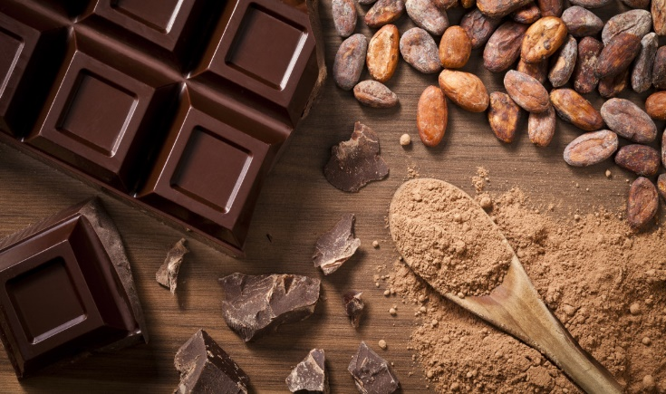

Art and Design:

Richard Meier

Pop Art/cartoons - Roy Lichtenstein/Keith Haring

DT: Designing a navigation tool

PE

Volleyball (Mr Tanner)

Dance (Mrs Gilby)

Computing

Creating media – web page creation

English

Non-fiction: Dragonology

Fiction: The Ice Bear

Non-fiction: The Everyday Journey of Ordinary Things

**Hawks Topic Plan**

**Spring 2022**

**Chocolate**

Music

(Oak National Academy)

Musical processes

RE

(Understanding Christianity)

What did Jesus do to save Human Beings?

Maths

(Maths No Problem)

Y5: graphs, fractions, decimals

Y6: measurements, ratio, algebra

Geography

What could we eat if we did not have imports?

History

How do we know the Aztecs valued chocolate?

Science

Properties and Changes

(Y5 National Curriculum unit)