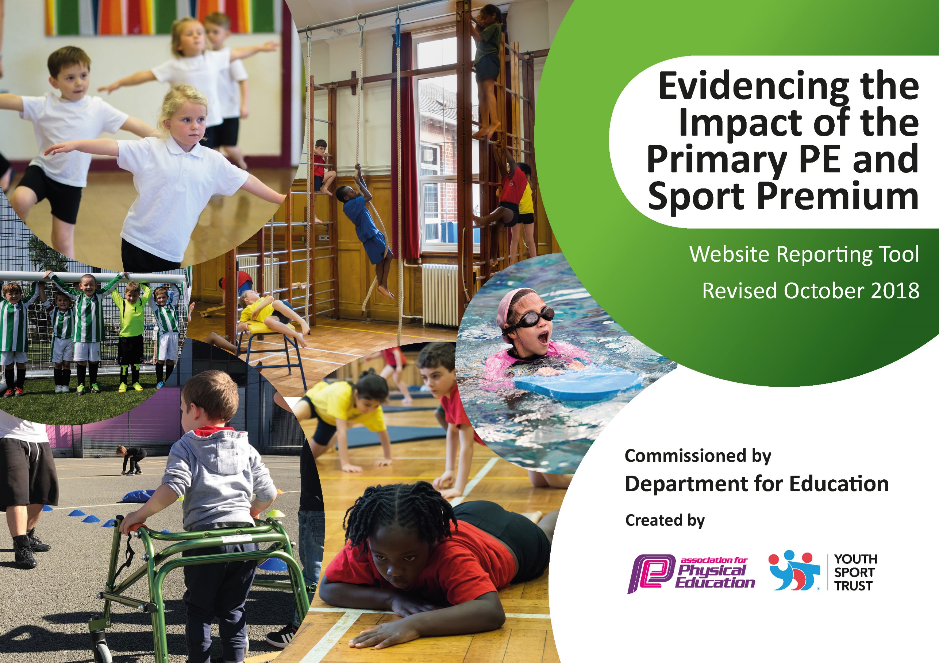
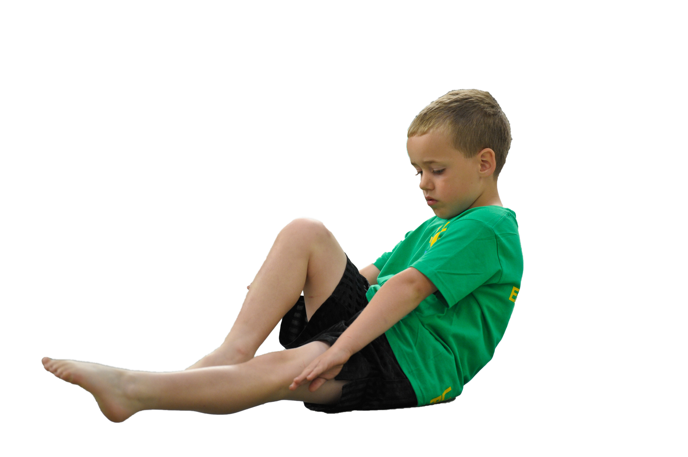
Schools must use the funding to make additional and sustainable improvements to the quality of Physical Education, Sport and Physical Activity (PESPA) they offer. This means that you should use the Primary PE and Sport Premium to:

- Develop or add to the PESPA activities that your school already offer
- Build capacity and capability within the school to ensure that improvements made now will benefit pupils joining the school in future years

Please visit gov.uk for the revised DfE guidance including the 5 key indicators across which schools should demonstrate an improvement. This document will help you to review your provision and to report
your spend. DfE encourages schools to use this template as an effective way of meeting the reporting requirements of the Primary PE and Sport Premium.

We recommend you start by reflecting on the impact of current provision and reviewing the previous
spend. Under the Ofsted Schools Inspection Framework, inspectors will assess how effectively leaders use the Primary PE and Sport Premium and measure its impact on outcomes for pupils, and how effectively governors hold them to account for this.

Schools are required to publish details of how they spend this funding as well as on the impact it has on pupils’ PE and sport participation and attainment by the end of the summer term or by 31 July 2019 at the
latest.
We recommend regularly updating the table and publishing it
on your website throughout the year, as evidence of your
ongoing review into how you are using the money to
secure maximum, sustainable impact. To see an
example of how to complete the table please
click HERE.

Support for review and reflection - considering the 5 key indicators from DfE, what development needs are a priority for your setting and your students now and why? Use the space below to reflect on previous spend, identify current need and priorities for the future.

Key achievements to date: | Areas for further improvement and baseline evidence of need:
Saints South West.  Morning routine revamp.  Attended festivals and sports events run by SSP.  Attended festivals and sports events run by Link Academy Trust.  Celebration Assemblies – opportunities to share sporting achievements inside and outside of school.  Outdoor Adventurous Activities - Residential Trips  School Sports Day | No longer joining the SSP for the next year but still to seek alternative provision for competitions next year.  Ensure all children are able to attend competitions and festivals across all age groups.  Continue with Sports Star of the Week but improve it with a Sports Star of the Half Term.  House Teams and Captains revamp.

Meeting national curriculum requirements for swimming and water safety | Please complete all of the below:
What percentage of your current Year 6 cohort swim competently, confidently and proficiently over a distance of at least 25 metres?  N.B. Even though your children may swim in another year please report on their attainment on leaving  primary school. | 100%
What percentage of your current Year 6 cohort use a range of strokes effectively [for example, front crawl, backstroke and breaststroke]? | 100%
What percentage of your current Year 6 cohort perform safe self-rescue in different water-based situations? | 100%
Schools can choose to use the Primary PE and Sport Premium to provide additional provision for swimming but this must be for activity over and above the national curriculum requirements. Have you used it in this way? | Yes/No

Action Plan and Budget Tracking
Capture your intended annual spend against the 5 key indicators. Clarify the success criteria and evidence of impact that you intend to measure to evaluate for students today and for the future.

Academic Year: 2018/19 | Total fund allocated: £4350 | Date Updated: 10.07.19
Key indicator 1: The engagement of all pupils in regular physical activity – Chief Medical Officer guidelines recommend that primary school children undertake at least 30 minutes of physical activity a day in school |  |  |  | Percentage of total allocation:
 |  |  |  | %
School focus with clarity on intended impact on pupils: | Actions to achieve: | Funding allocated: | Evidence and impact: | Sustainability and suggested next steps:
Run a new morning routine with different activities each day to develop different areas of physical activity.  Run an after-school childcare club 4 times a week to which promotes physical activity. Pupils participate in a range of team games and sport challenges.  All children have 2 hours of curriculum PE. 1 hour of outdoor, striking fielding/invasion games and 1 hour or dance/gymnastics. | Create a new weekly plan and folder of activities that can be used to support delivery. Promote to children and parents – create new posters to encourage participation.  Saints South West to run 3 after-school clubs and Premier Sports to offer an alternative sports club after-school to increase range of sports and activities offered.  Saints South West to provide one hour of teaching (teachers to use as CPD) and teachers to deliver the other hour. Teaching to be monitored and recorded to ensure it is happening. | £0 (teacher time)  £350  £4000 (as part of the central funding pot for the Link Academy Trust) | All teachers have been taking a session on the same day as their duty. Children are more excited for each activity. Have trialled using older children to demonstrate and support.  Some of the SSW sessions have been inconsistent but have met and spoken with them about activities moving forward. Children have enjoyed Premier and alternative sports – although registers have varied.  Teachers have learnt a lot from using sessions as CPD. Some teachers have not been as confident in certain areas but SSW have provided support and materials for this and have developed teacher confidence. | Using house captains to lead sessions and support their house teams. Change the activities every term to ensure children are staying motivated. Introduce a games morning where children play sports games in the morning. Record running on a Friday – awards system.  SSW to run 2 sessions a week for after-school provision. Premier to run their alternative sports club still but introduce new activities and sports. Look at linking them to clubs outside of school for children to develop further e.g. local fencing club.  New Academy PE Coordinator (previously from SSW) to still provide CPD and one hour session with each class per week. Teachers to still teach one lesson per week but will have more access and support for new sports/sports they are unsure about. Check rolling programme with teachers before the start of the term and check if any extra support is needed. Teachers to make notes during sessions which will contribute towards their own CPD folder to develop teaching and skills.
Key indicator 2: The profile of PESSPA being raised across the school as a tool for whole school improvement |  |  |  | Percentage of total allocation:
 |  |  |  | %
School focus with clarity on intended impact on pupils: | Actions to achieve: | Funding allocated: | Evidence and impact: | Sustainability and suggested next steps:
Organise a sports week that links to healthy living.  Opportunities to attended sport events within the wider community.  Introduce House Sports Teams across the whole school with house captains in Year 6. | KS1 And KS2 to have their own adventurous activity days. Visitors to be booked and contacted for in-school events.  Making stronger links within the academy to promote opportunities for every child to take part in PA and SS.  Children to be voted as house captains. House captains to meet and make decisions about morning routines and consider how they can help promote sport and PA across the school for every child. How can they get everyone active? | £2000  £0 (as part of central Academy payment)  £0 (teacher time) | KS1 – Plymouth Ski Centre  KS2 – Adrenaline Quarry  Visitors from professional sports teams (Plymouth Albion) and other key visitors to help whole school promotion of PE and PA (including doctors and health professionals etc.)  Every child had the opportunity to attending a sports event from Y1 – Y6.  House Captains were introduced but not fully set-up. Rolling action for next year. | Ensure promotion and meaning behind ‘Healthy Living Week’ is clear. Ensure lots of promotion with families and children. Consider adventurous activities that could be adapted and undertaken in school to help reduce costings if needed. Using the surrounding local environment (e.g. Trail Running). Getting parent involvement.  Continue to make links with other school in the academy. Look in to inter-school competitions (alongside house captains) to ensure children are getting every opportunity to take part in PA and sport.  XX

Key indicator 3: Increased confidence, knowledge and skills of all staff in teaching PE and sport |  |  |  | Percentage of total allocation:
 |  |  |  | %
School focus with clarity on intended  impact on pupils: | Actions to achieve: | Funding  allocated: | Evidence and impact: | Sustainability and suggested  next steps:
Improving the subject knowledge and confidence of teacher’s delivery of PE and sport.  PE leader to provide resources for staff to aid planning and delivery of lessons. | Organise one staff meeting every half term linked to the curriculum map focus. Finding and encouraging staff to attend CPD opportunities.  Create resource packs for different sports and year groups to support teachers with planning and delivery of a variety of sports and activities. | £0 (as part of Academy money)  £0 (as part of Academy money/teacher time) | All staff had the opportunity to attending CPD at the start of the year. CPD was given between joint school groups and therefore knowledge was shared. CPD was selected by staff to ensure it was worthwhile and expanding knowledge, not repeating.  Online space has been created with access to the main curriculum areas for teachers to access resources. Folders are checked regularly and teachers can upload extra information and resources as they please which allows greater sharing of knowledge and an ever-growing resource bank for staff to use if needed. | Teachers are more confident in teaching different areas of PE and therefore children can receive greater exposure to a range of sports and activities. PE leaders have also had extra meetings and training and therefore can support with running school-based CPD sessions for staff.  A main space has been created that all teachers can access. This is already full of resources and is continuing to be developed. Rolling programme allows resources to be reused and ensure continuous improvements are being made.
Key indicator 4: Broader experience of a range of sports and activities offered to all pupils |  |  |  | Percentage of total allocation:
 |  |  |  | %
School focus with clarity on intended  impact on pupils: | Actions to achieve: | Funding  allocated: | Evidence and impact: | Sustainability and suggested  next steps:
School Sports Partnership. Attending festivals and non-competitive events to introduce pupils to a variety of sporting activities.  Events as part of school partnership (Link Academy Trust group)  Healthy Living Week | Booking one event per term per key stage.  One event every half term for a set year phase. Every phase to have the opportunity to compete twice across the year. Ensuring events are suitable for whole classes to allow everyone to participate.  Book an event for KS1 and KS2 where they can attend an outdoor adventurous activity that is different to what they usually receive in school. | £0 (from above spending as part of SSP)  £0 (from Academy payment)  £0 (already accounted for above) | Events were attended by children from KS2 (KS1 event was cancelled).  Children attended events across the Academy twice in the year. There were also more specific opportunities for further sporting events, such as, an Academy wide Sports Day Athletics Competition.  Every child from the school had the chance to go off-site for an alternative/adventurous activities day. All children also got the chance to experience new sports within school and met sports star for different sports which helped promote a range of sports. | Link with community sports clubs to promote continuation of participation.  Ensure links are kept up with schools from across the Academy. Ensuring play leaders/Sports Captains keep up-to-date with training and running of events to help in the future.  Ensure children are getting exposure to a range of sports and events every year (not just doing the same trips). Use children’s ideas to ensure children are invested in decisions.
Key indicator 5: Increased participation in competitive sport |  |  |  | Percentage of total allocation:
 |  |  |  | %
School focus with clarity on intended  impact on pupils: | Actions to achieve: | Funding  allocated: | Evidence and impact: | Sustainability and suggested  next steps:
School Sports Partnership. Attending competitive events to allow pupils to develop their skills within more specific sports.  Attend central competitive sports events for Link Academy Trust Schools, e.g. netball and tag rugby tournaments, including Link Academy Trust Sports Day. | Book events through partnership, at least one a half term – competitive.  Selected students to participate in certain events (Sports Day – elite sports event) but also whole class attendance in other competitive sports. Mainly KS2 as competitive. | £0 (already allocated above)  £0 (already accounted for above) | Events were attending (on average 1 a half term) including central venue and league style competitions that encouraged children as it was on-going throughout the year.  Using local sports stars to help promote competitive sport. Awards for teams/schools that win competitions (encouragement through winning and pride). | Children want to take up sports in their own time and extra-curricular. Ensure children are all getting opportunities for competitive games (not just G&T/those who can do after-school events).  Linking to local sports clubs and promoting children to join clubs and encourage competitive sports.

