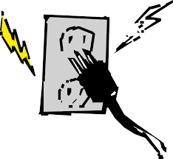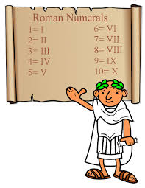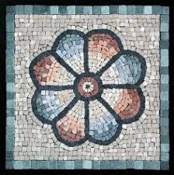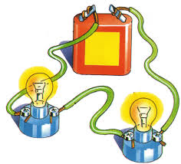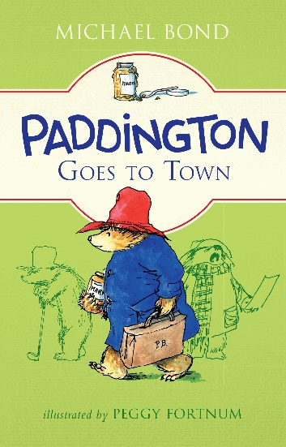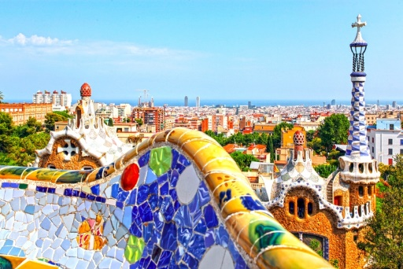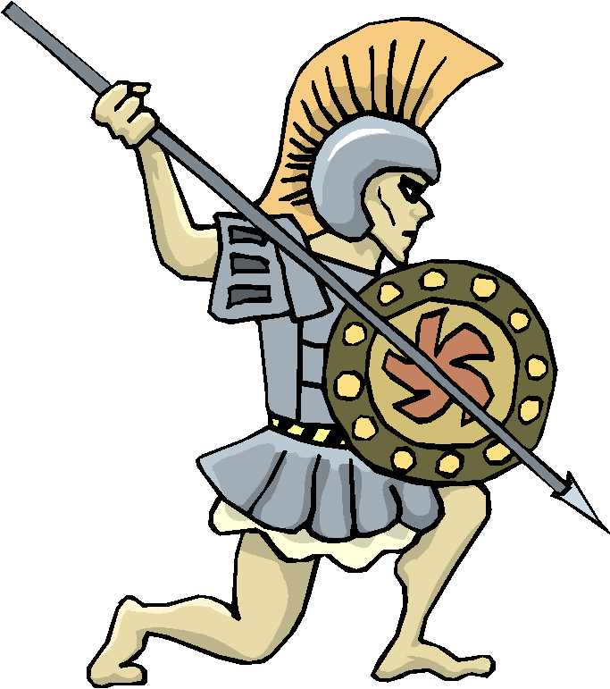

**Science:** Writing up conclusions and evaluations for experiments.

**ENGLISH:**

**Fantastically Great Women who Change the World**

*Non-fiction*

Writing a biography of a famous person, thinking about how our writing style can match their personality.

**Art:** Create our own Roman floor mosaic using printing skills. Thinking about natural colours and shapes

**Subjects taught on their own**

**Maths :** Year 3 Numbers to 1000/addition and subtraction.

Year 4 numbers to 10,000/addition and subtraction.

**Spanish:** holding conversations about ourselves and food.

**Music:** body percussion

**RE:** What does it mean to be a Muslim in Britain today?

**Science: Electricity**

What appliances run on electricity?

**Computing:** Immersion day

What is the internet and how can we believe what we read there?

**FINAL EVENT:** Consolidate our learning about the impact that the Romans had on Britain. Create a comparison diagram of the things which we use in our lives today with things which were brought by the Romans.

**HOOK:** Making posters about the Romans. We will look at the timeline of the Roman empire, why they invaded and start to think about what they changed about Britain

Take a ‘museum walk’ around our classroom to investigate Roman artefacts.

**ENGLISH: Paddington Goes to Town**

Writing our very own Paddington stories. Thinking of our own adventure and mischief for Paddington to get in to.

**Forest school**

**Science:**

What is a circuit? We will make predictions about what happens to a lamp when we change our circuits.

**ENGLISH: Paddington Goes to Town.**

Writing our own Paddington story based on the book of ‘Paddington Goes to Town’. We will focus on how we can create speech in our stories.

**History:**

What did the Romans do for Britain? We will thinking about inventions in our own lives that the Romans brought to Britain.

**Art:** Comparing the work of Gaudi to modern mosaic artists

**Art:** Creating our own Roman mosaic floor

**Art:** Who is Guadi? Using different shades of colours to create mosaics.

**History:** Who are the Romans? What is the Roman Empire and why did they come to Britain?

**Computing:** Using our skills learnt about how to use the internet safely to research the Romans and find reliable sources

Remarkable

Romans

**PE:** Basketball