Australia Day
Thursday 30th June 2022
Main:
“Snags” (Sausages) and Wedges
Quorn “Snags” (Sausages) and Wedges (v)
Jacket Potato with Cheese, Beans or Tuna (v)
All served with BBQ Beans, Chargrilled Corn Cobs and Fresh Salad
Dessert:
Anzac Biscuit
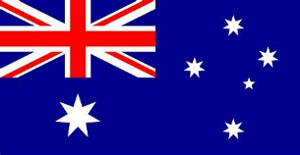
Yoghurt or Fresh Fruit

