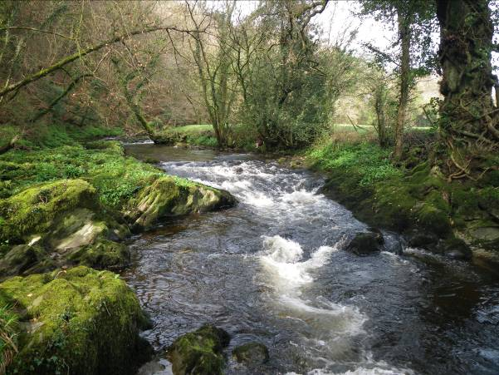

Music

Pulse and Metre

Maths

Both: Further multiplication and division

Y3: Measurement

Y4: Fractions

**Kingfishers Topic Plan**

**Spring 1**

**Rivers and Coasts**

Geography

Spring 2

Why might we find fossils of sea creatures in cliffs today?

English

Fiction: Lord of the Forest

Non-Fiction: Until I met Dudley

Fiction: The Beasties

Poetry: Poetry Pie

Art

Mark making - water theme

DT

Eating Seasonally

RE

What does it mean to be a Hindu in Britain today?

Geography

Spring 1

What features do you find on rivers or coasts?

**PE**

Volleyball

Computing

Photo editing

Science

Animals including humans