Italian Day
Thursday 7th October
Main:
Cheesy Pizza Muffins served with potato wedges (v)
Tomato Pasta Bake (v)
Jacket Potato with Cheese, Beans or Tuna (v)
All served with Sweetcorn and Fresh Salad
Dessert:
Italian Meringue, Cream and Fresh Fruit
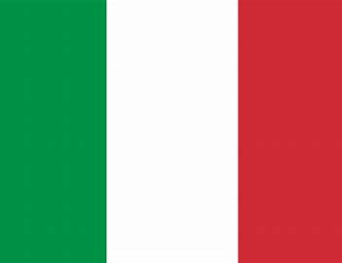
Yoghurt
Fresh Fruit

