Diptford C of E Primary School
Diptford, Totnes, Devon. TQ9 7NY
Tel: 01548 821352 Email: admindiptford@thelink.academy

Wednesday 2nd March 2022
Dear Parents,

I am sure you will be aware of the changes to COVID guidance and expectations of Living with COVID which came into place on February 24th. Following this latest guidance, we are advised that we still have a legal duty to risk assess, so you will find our latest RA100 on the school website.

Key messages are as follows:

Control measures to remain in schools to reduce risk:
- Ensure good hygiene for everyone.
- Maintain appropriate cleaning regimes.
- Keep occupied spaces well ventilated.
- Follow public health advice on testing, self-isolation and managing confirmed cases of COVID-19
- Face coverings are no longer advised for pupils, staff and visitors in classrooms or communal areas. Staff and pupils should follow wider advice on face coverings outside of school, including on transport to and from school. (The legal requirement to wear a face covering no longer applies. However, the government suggests that you continue to wear a face covering in crowded and enclosed spaces where you may come into contact with people you do not normally meet).
- Self-isolation: · If someone develops symptoms or has a positive test result the guidance still advises people to stay at home to avoid passing the infection on to others. Many people may no longer be infectious after 5 days and so as previously, if people have no temperature and negative LFD tests on day 5 and 6 the risk of them being infectious greatly reduces and so can safely return to normal routines.
- The schools operational guidance outlines that in most cases parents and carers agree that a pupil with the key symptoms should not attend the school given the potential risk to others. If a parent or carer insists on a pupil attending our school as a confirmed or suspected case of Covid-19, we can take the decision to refuse the pupil if, in our reasonable judgement, it is necessary to protect other pupils and staff from possible infection with Covid-19. We are advised to communicate this to parents and encourage parents to follow the latest guidance around isolation if symptomatic.
- Close contacts are no longer required to self-isolate or advised to take daily tests and contact tracing has ended.
- Testing: PCR testing is still currently available for anyone with Covid-19 symptoms.

Diptford C of E Primary School
Diptford, Totnes, Devon. TQ9 7NY
Tel: 01548 821352 Email: admindiptford@thelink.academy

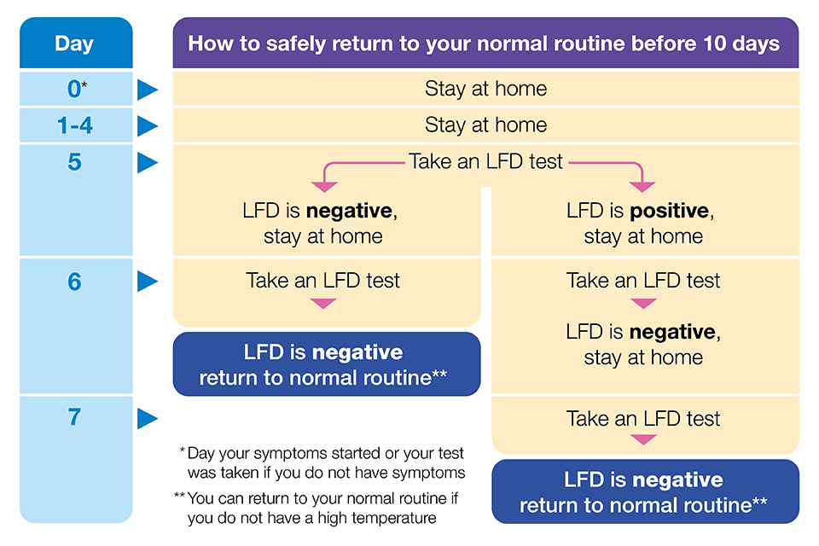

I hope this information is useful and keeps you informed of how the future looks for schools at this time.

Many thanks for your continued support,
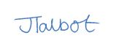
Jodie Talbot
Academy Head

