Mozambique Day
Thursday 11th November
Main:
Peri-Peri Style Chicken with Rice
Vegetable Curry with Rice (v)
Jacket Potato with Cheese, Beans or Tuna (v)
All served with Garden Peas and Fresh Salad
Dessert:
Mozambique inspired Citrus Cake (Lemon and Orange Iced Sponge)
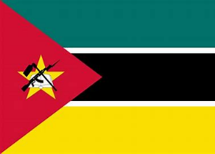
Yoghurt
Fresh Fruit

