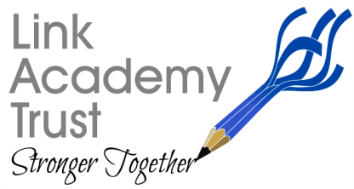
LINK ACADEMY TRUST
L a n d s c o v e S c h o o l H o u s e
L a n d s c o v e , Nr A s h b u r t o n
Devon. T Q 1 3 7 L Y
T e l : 0 1 8 0 3 7 6 2 1 1 3

Second Pandemic Lockdown

Dear Parent/ Carer,

Following this evening’s 8pm announcement by the Prime Minister I am writing to set out what will happen tomorrow for pupils in Link Academy Trust schools.

We are extending todays INSET or Non-pupil day for a further day so that staff can come into school and make detailed preparations for the coming 6 weeks of online learning. We wish to start the period fully organised to deliver the highest quality teaching and learning online and intend to use this day to make sure we have made arrangements for in-school teaching and learning for key worker pupils, although there is no obligation that keyworker pupils come into school if it is preferable for them to access online learning.

Once these preparations are in place, we will make sure you are fully aware of all the arrangements and will ensure we are able to produce online learning to cover all areas of the National Curriculum.
Online learning timetables will be available on Wednesday from your child’s class teacher for Wednesday 6th January.

We will resume calling families who may require support weekly from next week.

Arrangements for Free School Meals provision for those entitled will also be set up.

Tomorrow, keyworker pupils can attend school to enable parents to work but if you can delay this tomorrow it would be really helpful to staff. Early years pupils are in the same position.

Thank you for your patience and understanding given the short notice we receive to implement such extensive changes.
Yours sincerely,

Nicky.

Nicky Dunford. CEO, The Link Academy Trust.

