**Umbrella Narrative**

English

Books:

* Super Duper You
* Can I build another me?

Your child will be accessing a range of mark making activities appropriate to their individual needs. This includes reading and retelling stories, learning about the structure of stories.

Year 1s will be creating lists, making questions and answers and writing their own story.

**HOOK:**



New beginnings

All about me

Getting to know you

***Dippers Class***

***Who’s who?***

***Autumn 2019***

Final event:

What makes us special?

Navaratri festival

Diwali 27th October

Bonfire night

**RE**

Being Special

How we are all different but all as special as each other

**Art**

* Exploring different materials,
* Colour mixing
* Painting pictures

PE

PE will happen on a Wednesday this term. The children will be learning ball skills, including throwing and catching.

*Who’s*

*who?*

Maths

* Counting and recognising numbers
* Reading and writing numbers to 10
* Adding and subtracting different objects

Phonics

Reception: Phase 3 phonics

Year 1: Phase 5 phonics



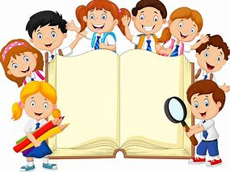

Understanding the World

We will explore the following:

* Harvest Festival
* Birthdays
* Important people
* Diwali
* The World around us

Science –

Plants – over the first part of the term we will be focussing on ‘plants’ the children will plant bulbs and observing them as they grow.

Seasonal Changes

Computing

* Using Beebots
* Taking pictures with an iPad
* Using different apps