 | 8:50 – 9:00 | 9:00 – 10:00 | 10;00 –  11:00 |  | 11:00 – 11:15 | 11:15 – 12:15 | 12:00 – 1:15 | 1:15 – 1:30 | 1:30 – 2:10 |  | 2:00 – 2:50 |  | 2:50 – 3:10 | 3:15
Monday | Wake and Shake | Literacy | Maths  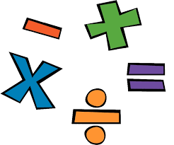 |  | Break | Phonics  Handwriting | Lunch | Afternoon activities | Art with KG & SS (PPA) |  |  |  | Collective Worship | Home Time
Tuesday |  | Literacy | Maths |  |  | Phonics  Handwriting |  |  | PSHE | 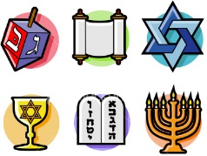  RE |  | Collective Worship 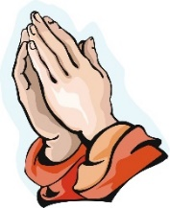
Wednesday |  | PE | Maths |  |  | Literacy |  |  | CW in Church |  | 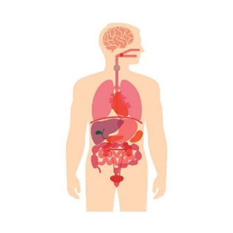  Science
Thursday |  | Literacy | Maths |  |  | Phonics  Handwriting |  |  | Forest School |  |  |  | Collective Worship
Friday |  | Topic based learning |  | Spellings  Home  work |  | Guided Reading  Phonics |  |  | Guided Reading |  |  |  | Achievers Assembly

