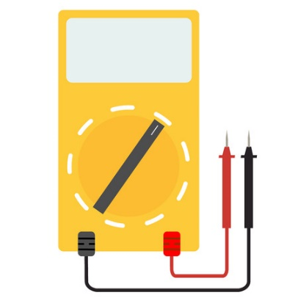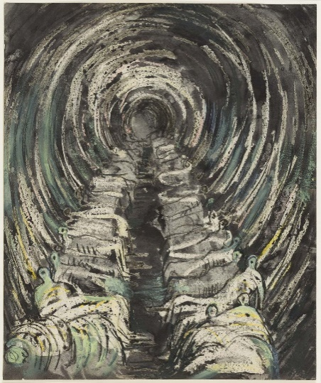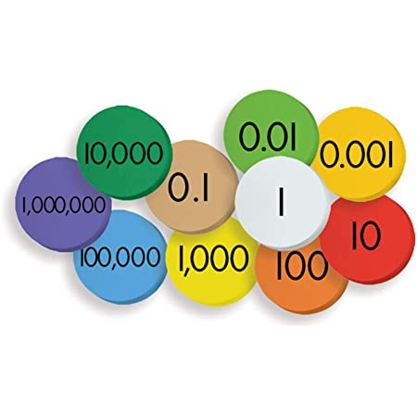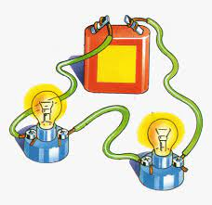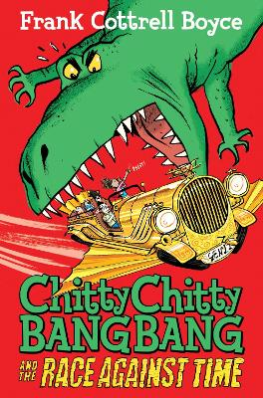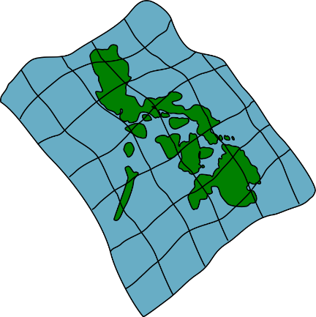

**Art:** Create a ‘final piece’ of artwork in the style of Henry Moore.

**ENGLISH: TINS –** Independent writing. Create own chapter for the book where the Tooting family visit the WW2 era. Building suspense through writing.Comment and self-assess own writing. Share stories with other children.

.

.

**Geography:** Creating maps using Plymouth as a basis and making comparisons between Plymouth before and after the war and then today.

**Science:** Using voltages to change the brightness of a bulb or loudness of a buzzer, experimenting variables in circuits

**Science:** Electricity – making circuits, exploring and using symbols in diagrams for circuits

**Art:** Experimenting with different mediums and using charcoal

**Geography:** 4 and 6 figure gird references, using a key and understanding map symbols.

**Maths:**

Y5: Making number patterns and rounding

Y6: Using mixed operations and multiplying by 2 digit numbers

**Art:** Introduction to Henry Moore Explore and analyse artwork.

**Science: Voltage and Cells –** what are they and how are they used?

**ENGLISH: Chitty Chitty Bang Bang and the Race Against Time –** Creating storyboards, using own images to create a story based on travelling to a time during the World War. Writing a draft story to then edit and improve; focusing on grammar learnt and spellings.

.

.

**Geography:** What are OS maps and how do we use them?

**ENGLISH: Chitty Chitty Bang Bang and the Race Against Time –** immersion in text. Reading through the story, whilst predicting what might happen. Drawing inferences and considering characters feelings as well as thoughts and motives from their actions. Exploring vocabulary and grammar used and considering why an author might use it and the effect it has on a reader.

.

.

**HOOK:** Explore images and videos from WW2.

Look at images of Plymouth and compare from WW2 and now – what is similar or different?

Watch videos from the Blitz and explore how it changed the landscape of Plymouth. Why were certain places targeted in particular?

**Maths:**

Y5 – Reading, writing, and comparing numbers to 1 000 000

Y6 – Reading, writing, comparing, and rounding numbers to 10 000 000

**ENGLISH: Chitty Chitty Bang Bang and the Race Against Time –** Grammar lessons:

* Use and punctuate direct speech.
* Relative clauses
* Parenthesis
* Perfect form and passive tense (verb tenses)
* Expanded noun phrases

.

**Other discrete subjects**

**Spanish:** Talking about the town

**Music:** OAK Academy – Pitch

**Computing:** Computer networks and systems (Y6)

**RE:** Hinduism (Y6)

**PSHE/SRE:** Being me in my world (Y6)

**PE:** Inter-academy basketball festival

**FINAL EVENT:**

Consolidate main question and use evidence learnt from throughout unit to explain how the war changes Plymouth and its landscape.

Use artwork to convey landscapes and changes during the war.

**PE:** Basketball and Tag Rugby

World at War: How did the war change people’s lives?