Diptford Long Term Curriculum Map 2019-2021
 | Autumn | Spring | Summer
Reception & Year 1  A | Who’s who? | Sail the seven seas | Amazing Animals  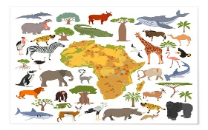
Hook or visit | Visitors to school & Riverford Farm | Buckland Abbey | Zoo
Reception & Year 1  B | Are we there yet? | People and Places | Once upon a time
Hook or visit | Round Robin | Exeter Cathedral | Theatre Trip
Year 2 & 3  A | Dartmoor Rocks!  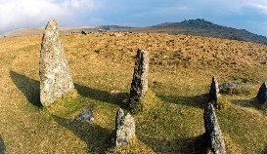 | Incredible India | Tokyo 2020
Hook or visit | Merivale, Dartmoor | Visitor | Healthy Living Week
Year 2 & 3  B | Wild Weather | Fire Fire!  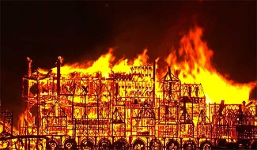 | Roots, shoots & muddy boots
Hook or visit | Met Office visitor | Fire Station | Forest School Day
Year 4, 5 & 6  A | Vicious Vikings | Walk like an Egyptian | Chocolate
Hook or visit | RAMM Museum | Egyptian Day | South Devon Chilli Farm
Year 4, 5 & 6  B | Out of this World | Remarkable Romans  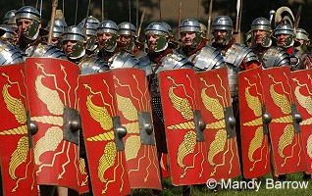 | Rule Britannia
Hook or visit | STEM Centre | Merrivale, Ipplepen dig | London

