[](http://www.google.co.uk/url?sa=i&rct=j&q=&esrc=s&source=images&cd=&cad=rja&uact=8&ved=0ahUKEwiv6oT57I7LAhWGQBoKHXMtAUgQjRwIBw&url=http://worldartsme.com/yellow-umbrella-clipart.html&psig=AFQjCNFaswc03h8xdYKPm2SpMujpXd3UMA&ust=1456350050307846) **Umbrella Narrative:**

***Topic: Ourselves***



**Ourselves**

**Mathematics:**

• Recognise some numerals of personal significance.

• Recognises numerals 1 to 5.

• Counts up to three or four objects by saying one number

name for each item.

• Counts actions or objects which cannot be moved.

• Counts objects to 10, and beginning to count beyond 10.

• Counts out up to six objects from a larger group.

• Selects the correct numeral to represent 1 to 5, then 1 to 10

objects.

• Counts an irregular arrangement of up to ten objects.

• Estimates how many objects they can see and checks by counting them.

*Examples- estimating and counting socks/ consolidate number recognition with birthday cards/ explore ordering and comparing size people and body parts.*

**Final event:**

*Linked to ‘Healthy Me’*

**Fit Friday on 2nd November**

Children will make healthy snacks to sell at playtime and will lead the rest of the school in a fitness activity to promote Healthy Lifestyles across the school.



**RE:**

• Enjoys joining in with family customs and routines.

-Exploring Christianity: Harvest. Christmas. Ha

Explori

**Expressive Arts & Design:**

• Create simple representations of events, people and objects.• Initiates new combinations of movement and gesture in orderto express and respond to feelings, ideas and experiences.• Chooses particular colours to use for a purpose.• Introduces a storyline or narrative into their play. *Examples- painting portraits, footprints and handprints, role play areas.*

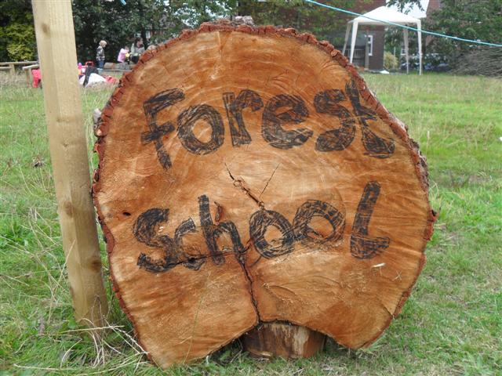

Forest School

Mondays

**Physical Development:**

Multi skills with the PE specialist

• Experiments with different ways of moving.

• Jumps off an object and lands appropriately.

**Understanding the World:**

Looks closely at similarities, differences, patterns and change.

*Examples- similarities and differences between each other, how humans grow and change, exploring 5 senses.*

**Literacy:**

• Continues a rhyming string.

• Hears and says the initial sound in words.

• Can segment the sounds in simple words and blend them together and knows which letters represent some of them.

• Gives meaning to marks they make as they draw, write and paint.

*Examples- rhyming words with parts of the body, initial sounds of healthy foods, writing ‘recipes’ for healthy snacks.*

.

PE: (Wednesday afternoon and Thursday mornings)

**DISCREET**

Exploring languages: Use different languages during registration.

Music: Friday afternoons

[](http://www.clipartpanda.com/clipart_images/children-this-clip-art-of-1199107)

**Ourselves**

Focus stories:

Funnybones (Janet and Allan Ahlberg)

Avacado Baby (John Burningham)

My Five Senses (Aliki)

Oliver’s Fruit Sald (Vivian French)

**Communication and language:**

• Uses language to imagine and recreate roles and experiences in play situations.

• Responds to instructions involving a two-part sequence. Understands humour, e.g. nonsense rhymes, jokes.

• Maintains attention, concentrates and sits quietly during appropriate activity.

*Examples- Role pay areas; ‘Photo Booth’, ‘Home Corner’, ‘Opticians’.*

Technology:

• Completes a simple program on a computer.

Exploring technology in the role play area.

**Music:**

• Begins to build a repertoire of songs and dances.

• Explores the different sounds of instruments.

*Example- ‘Head, shoulders, knees and Toes’.*

Physical Development:

Discuss ways of keeping healthy and encourage children to recognise the changes to their body when they are active.

Our bodies, our senses, what makes me special, how canI stay healthy.

**HOOK: ‘Let’s take a Selfie!’**

Children will be using the Ipads and camera to take selfies of themselves for our ’Photo Booth’ role play area. They will also use these photos to draw self portraits for our art display.

**Personal, Social and Emotional Development:**

*Confident to speak to others about own needs, wants, interests and opinions.

*Initiates conversations, attends to and takes account of what others say.

* Understands that own actions affect other people, for example, becomes upset or tries to comfort another child when they realise they have upset them.

Remembering & Understanding

Applying & Analysing

Evaluating & Creating