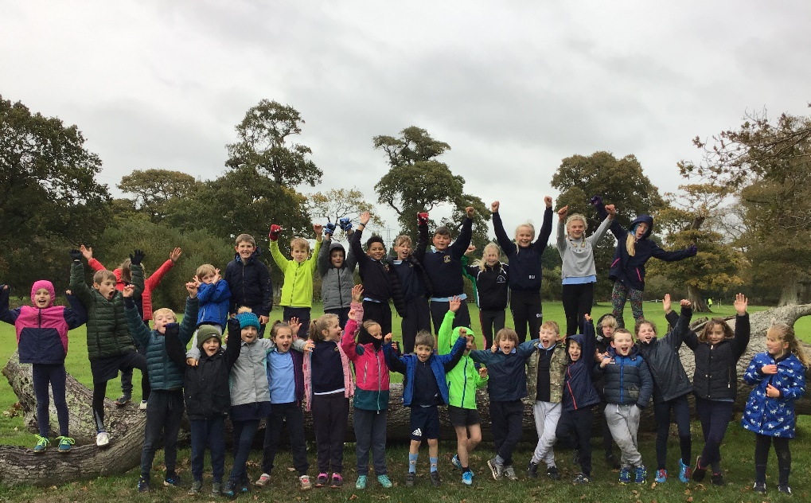
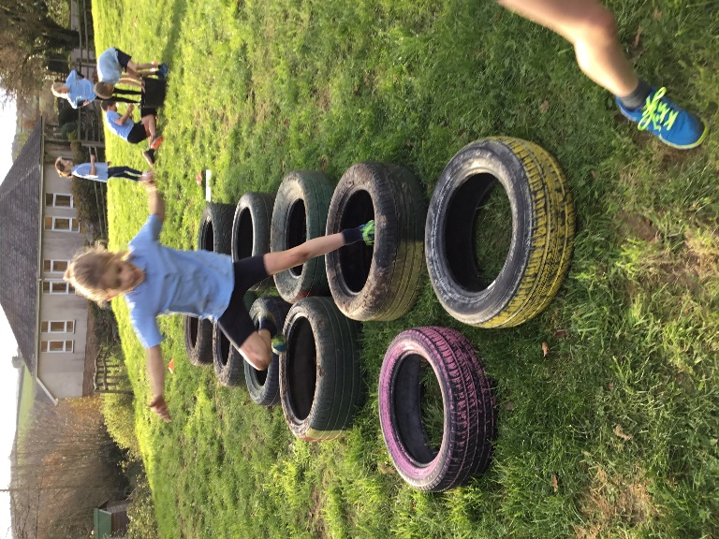
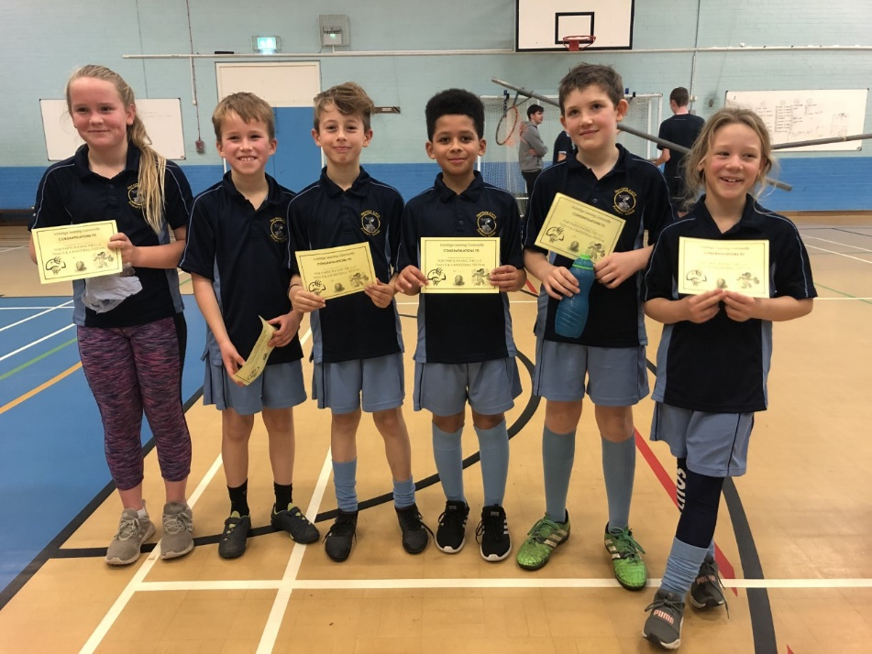
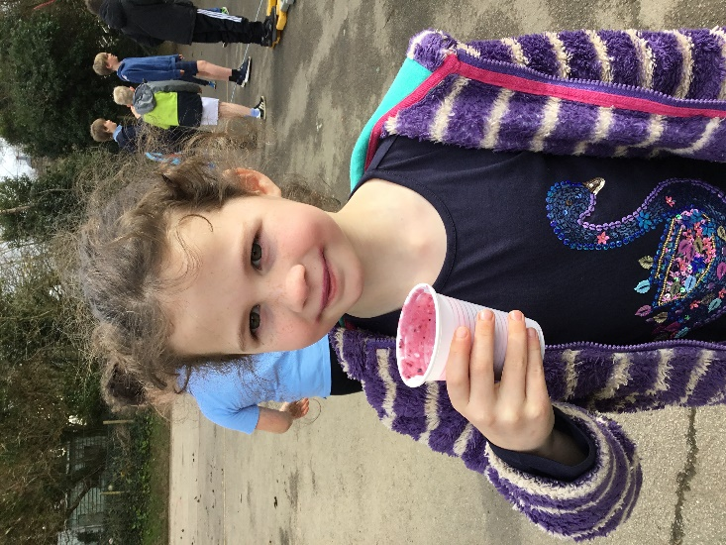
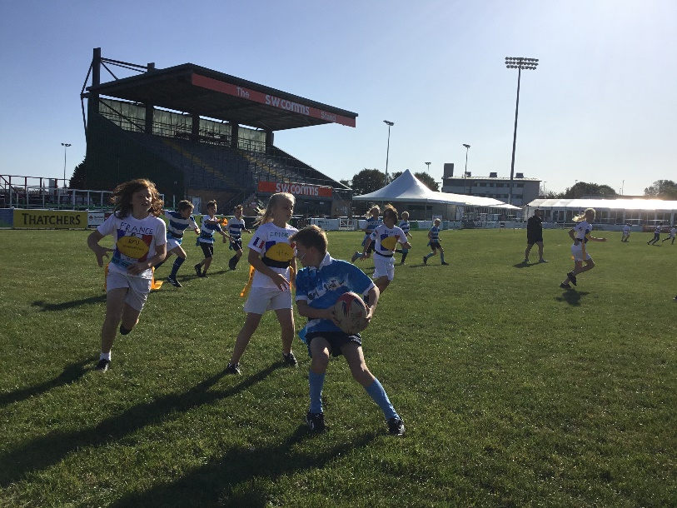
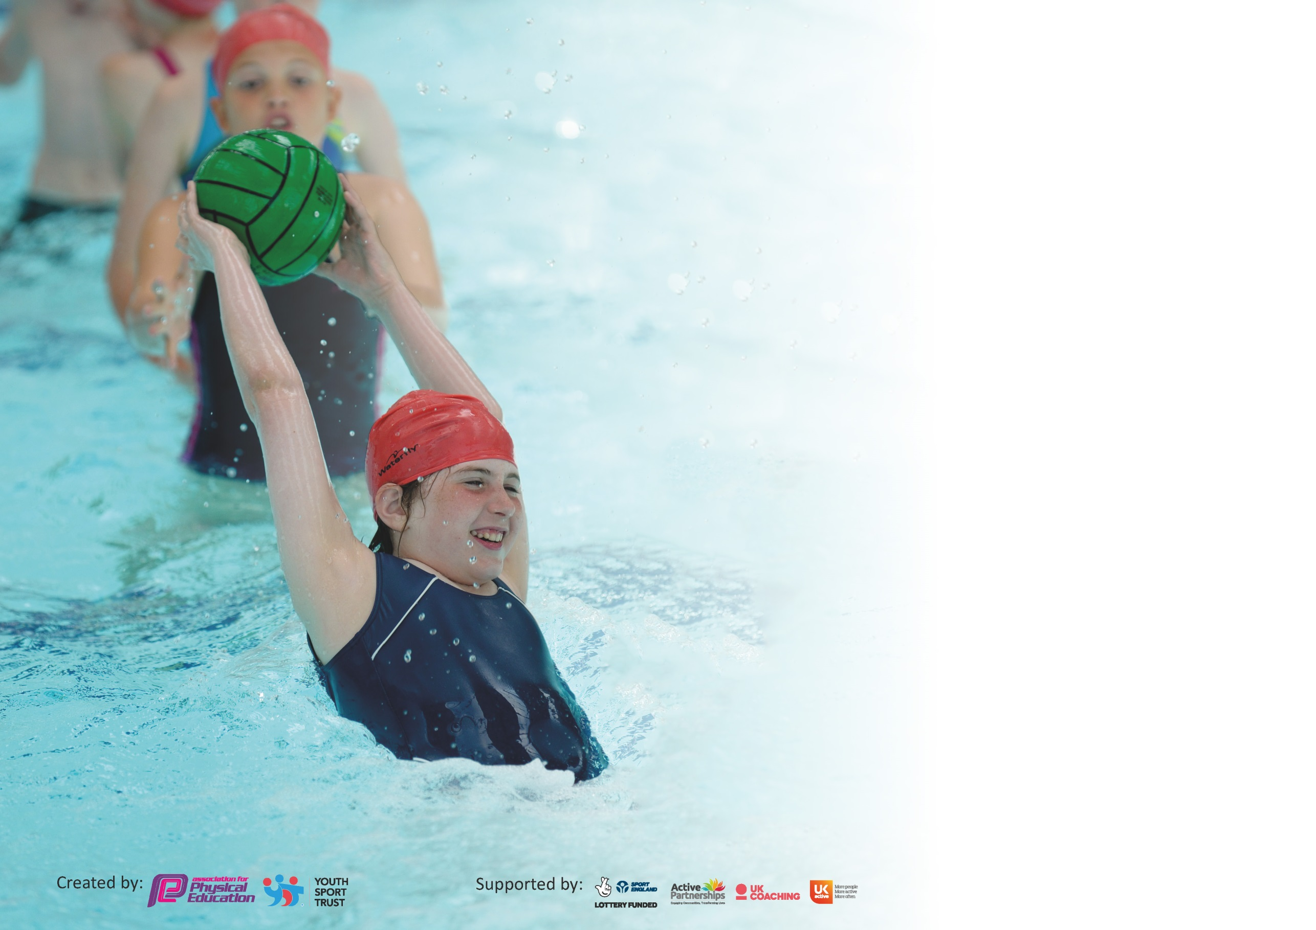

It is important that your grant is used effectively and based on school need. The Education Inspection Framework (Ofsted 2019 p64) makes clear there will be a focus on ‘whether leaders and those responsible for governors all understand their respective roles and perform these in a way that enhances the effectiveness of the school’.

Under the Quality of Education criteria (p41) inspectors consider the extent to which schools can articulate their curriculum (INTENT), construct their curriculum (IMPLEMENTATION) and demonstrate the outcomes which result (IMPACT).

To assist schools with common transferable language this template has been developed to utilise the same three headings which should make your plans easily transferable between working documents.

Schools must use the funding to make additional and sustainable improvements to the quality of Physical Education, School Sport and Physical Activity (PESSPA) they offer. This means that you should
use the Primary PE and Sport Premium to:

- Develop or add to the PESSPA activities that your school already offer
- Build capacity and capability within the school to ensure that improvements made now will benefit pupils joining the school in future years

Please visit gov.uk for the revised DfE guidance including the 5 key indicators across which schools should demonstrate an improvement. This document will help you to review your provision and to report your spend. DfE encourages schools to use this template as an effective way of meeting the reporting requirements of the Primary PE and Sport Premium.

We recommend you start by reflecting on the impact of current provision and reviewing the previous spend.

Schools are required to publish details of how they spend this funding as well as on the impact it has on pupils’ PE and sport participation and attainment by the end of the summer term or by 31st July 2020 at the latest.

We recommend regularly updating the table and publishing it on your website throughout the year. This evidences your ongoing self-evaluation of how you are using the funding to secure maximum, sustainable impact. Final copy must be posted on your website by the end of the academic year and no later than the 31st July 2020. To see an example of how to complete the table please click HERE.

Support for review and reflection - considering the 5 key indicators from DfE, what development needs are a priority for your setting and your pupils now and why? Use the space below to reflect on previous spend and key achievements and areas for development.

Key achievements to date until July 2020: | Areas for further improvement and baseline evidence of need:
- Children participate in a morning routine involving physical activity every day (Diptford Daily Dash)  - PE lessons are occurring at least twice a week (2 hours)  - All children have competed in inter-school sports and intra-school competitions across the academy (virtual due to covid-19)  - Sports recognitions during celebration assemblies (Sports Star of the Week/Achievements from outside of school)  - House Teams are up and running and all children can obtain house points across all learning to help their team, not just sport related.  - New play equipment is in the process of being constructed  - ASC Provision has been adapted and will be continued to be implemented over the coming year to ensure sustainability (and affordability as to not rely on budget as much)  COVID-19 STOPPED MOST SUMMER RESIDENTIALS, COMPETITIONS AND EVENTS FROM HAPPENING. | - Develop House Teams more and introduce House Assemblies and Inter-House competitions/days  - Personal Best (need to introduce as part of morning routine)  - Greater promotion of Sports Star of the week – potential for sports star of the half term/sportsmanship award  - Consider swimming interventions for children past Y3/4 who still might not be able to swim effectively or efficiently  - Look in to having visitors in and events at local sports clubs  - Ensure there is enough ‘play equipment’ for children to be able to be physically active during their play times  - Additional face-to-face festivals against other schools in the academy post covid-19.

If any funding from the academic year 2019/20 has been carried over you MUST complete the following section. Any carried over funding MUST be spent by 31 March 2021.

Sports Premium Carry-Over

Academic Year: September 2020 to March 2021 | Total fund carried over: £2000 | Date Updated: 26/03/2021
What Key indicator(s) are you going to focus on?  KI1, 2 and 4. |  |  |  | Total Carry Over Funding:
 |  |  |  | £2000
Intent | Implementation |  | Impact
Your school focus should be clear how you want to impact on your pupils. | Make sure your actions to achieve are linked to your intentions: | Carry over funding allocated: | Evidence of impact: How can you measure the impact on your pupils; you may have focussed on the difference that PE, SS & PA have made to pupils re-engagement with school. What has changed?: | Sustainability and suggested next steps and how does this link with the key indicators on which you are focussing this academic year?:
KI1 & KI2  KI4 - Give students a wide range of high-quality physical activities. | Central PE staffing costs  Resources purchased to allow greater breadth of activities taught within the PE curriculum. | £1500  £500 | Trust PE staff implemented a variety of online and school based learning for students during school closures. This included live morning PE lessons every day and weekly recorded lessons.  Students experience a greater number of new activities in curriculum PE and extra-curricular clubs. These activities have specialised equipment which has improved the quality of student’s learning. | Staff continuing to work for the trust and provide staff across the Link Academy Trust with resources, ideas and training in how to deliver high quality PE.  Purchased by the school and new activities have formed part of the new school PE curriculum, which is more varied than previous years.

Meeting national curriculum requirements for swimming and water safety.

N.B Complete this section to your best ability. For example, you might have practised safe self-rescue techniques on dry land.
What percentage of your current Year 6 cohort swim competently, confidently and proficiently over a distance of at least 25 metres?  N.B. Even though your pupils may swim in another year please report on their attainment on leaving primary school at the end of the summer term 2021. | %  N/A as swimming provision has been effected by COVID-19 restrictions.
What percentage of your current Year 6 cohort use a range of strokes effectively [for example, front crawl, backstroke and breaststroke]? | %  N/A as swimming provision has been effected by COVID-19 restrictions.
What percentage of your current Year 6 cohort perform safe self-rescue in different water-based situations? | %  N/A as swimming provision has been effected by COVID-19 restrictions.
Schools can choose to use the Primary PE and sport premium to provide additional provision for swimming but this must be for activity over and above the national curriculum requirements. Have you used it in this way? | No

Action Plan and Budget Tracking
Capture your intended annual spend against the 5 key indicators. Clarify the success criteria and evidence of impact that you intend to measure to evaluate for pupils today and for the future.

Academic Year: 2020/21 | Total fund allocated: £16,530 | Date Updated: September 2020
Key indicator 1: The engagement of all pupils in regular physical activity – Chief Medical Officer guidelines recommend that primary school pupils undertake at least 30 minutes of physical activity a day in school |  |  |  | Percentage of total allocation:
 |  |  |  | 52%
Intent | Implementation |  | Impact
Your school focus should be clear what you want the pupils to know and be able to do and about  what they need to learn and to  consolidate through practice: | Make sure your actions to achieve are linked to your intentions: | Funding allocated: | Evidence of impact: what do pupils now know and what can they now do? What has changed?: | Sustainability and suggested next steps:
All children have 2 hours of PE teaching per week within lesson times (with the addition of Fun Fit interventions and competitions/festivals)  All children to be taking part in physical activity every day. | Class teacher will teach one lesson a week with the other being taught by the Academy PE Lead.  Continue with ‘Diptford Daily Dash’ where children run in the mornings around the playground. Children to count their laps and record this as part of house teams as an incentive to run more/take part – this will also include a personal best element. | £8984 (as part of central money in the Academy)  £0 (teacher time) | Students have two hours of PE, which increases their physical activity levels. Also, having a specialist PE teacher deliver lessons ensure the quality of teaching is high and the students get a positive experience from the subject. | Academy Trust PE lead employed so will continue to deliver PE at the school.

Key indicator 2: The profile of PESSPA being raised across the school as a tool for whole school improvement |  |  |  | Percentage of total allocation:
 |  |  |  | 23%
Intent | Implementation |  | Impact
Your school focus should be clear what you want the pupils to know and be able to do and about  what they need to learn and to  consolidate through practice: | Make sure your actions to achieve are linked to your intentions: | Funding allocated: | Evidence of impact: what do pupils now know and what can they now do? What has changed?: | Sustainability and suggested next steps:
Suitable equipment is available to effectively teaching PE across every age group, in accordance to the curriculum map.  Notice Boards and Social Media to promote sport and PA.  Appreciation and celebration of global events, e.g. Rugby World Cup, 6 Nations, Olympic/Paralympic Games.  Develop PE in line with whole-school improvement plan - Give students access to greater ICT and video analysis opportunity to develop their learning. | Order new PE equipment for lessons, in line with the Academy curriculum map programme for 2020/21. Inventory of PE shed to be completed to ensure equipment can be ordered with enough time before teaching commences.  Link PE Lead to update these regularly and ensure variety of content.  Run a ‘mini-Olympics’ as part of sports day routines to promote physical activity alongside Tokyo 2021 Olympics.  Purchase of ICT resources to use for PE lessons. | £750  £0  £0 (as part of central pot)  £3800 | Students have access to specialist equipment for different topics within the PE curriculum.  Staff trained on how to use equipment which leads to higher quality lessons.  Students are aware of their learning and achievements in PE through seeing this on the notice board and social media. Social media has been a real driving force to show the parents and wider community how important PE is to our school.  Students have demonstrated their learning and linked their PE lessons to the upcoming Olympics.  Going forward iPads/ICT students have used ICT resourced in PE to enhance their understanding of skills and techniques, improving their learning in both PE and computer literacy, driving whole school and trust-wide improvement in these areas. | All equipment purchased and remains at school for future use. Money allocated next year to top up any essential items.  Will continue to be updated by PE lead next year as part of job role.  Major sport activities will be factored into teaching next year to ensure students are aware of wider sport and physical activities which take place around the world.  Use of technology in PE will be a continual focus across the school as part of the whole-school improvement plan.

Key indicator 3: Increased confidence, knowledge and skills of all staff in teaching PE and sport |  |  |  | Percentage of total allocation:
 |  |  |  | 0% (part of PE lead role – see KI1)
Intent | Implementation |  | Impact
Your school focus should be clear | Make sure your actions to | Funding | Evidence of impact: what do | Sustainability and suggested
what you want the pupils to know | achieve are linked to your | allocated: | pupils now know and what | next steps:
and be able to do and about | intentions: |  | can they now do? What has
what they need to learn and to |  |  | changed?:
consolidate through practice:
Teachers to be confident in teaching a range of sports and activities and understand the progressions involved.  Team Teaching and ‘informal’ observations to ensure consistency and development of teaching.  All teachers to have access to planning and resources to support areas they are not as confident in. | Link PE Lead to be shadowed by teachers when teaching to act as CPD. Teachers to also plan and team-teach with PE Lead to help develop skills and knowledge, in turn boosting their confidence. Check PE areas with individual teachers to ensure they are confident in teaching it.  Teachers to team-teach one lesson with Academy PE Lead once a half term (once per sport).  Planning and resources, including assessment documents via Link PE Lead and school-based PE Lead to ensure quality and progression of teaching across the school. | £0 (as part of central pot – see KI1 for reference to cost)  £0 (teacher time)  £0 (teacher time) | Teachers are delivering higher quality lessons and as such, students are making greater progress. New assessment procedure has identified this.  Staff are now confident delivering a wider range of activities, giving students access to a much broader range of sports within the PE curriculum.  Feedback given to staff by PE lead and together, have ensured that staff confidence is high. | Academy PE Lead employed so will continue with CPD over the next academic year and beyond.  Academy PE lead will continue as part of job role.

Key indicator 4: Broader experience of a range of sports and activities offered to all pupils |  |  |  | Percentage of total allocation:
 |  |  |  | 15%
Intent | Implementation |  | Impact
Your school focus should be clear | Make sure your actions to | Funding | Evidence of impact: what do | Sustainability and suggested
what you want the pupils to know | achieve are linked to your | allocated: | pupils now know and what | next steps:
and be able to do and about | intentions: |  | can they now do? What has
what they need to learn and to |  |  | changed?:
consolidate through practice:
Curriculum map has been designed by PE leads from across the academy to ensure all children are getting exposure to a range of activities also.  Forest School to provide outdoor education.  Children to experience alternative or adventurous activities.  Extra-curricular opportunities for every child from YR to Y6.  Mental Health resource delivered to all pupils to broaden their understanding of how mental and physical health are important. | Check curriculum map at PE leader hub meetings. Ensure activities are not repeated (unless necessary) to provide a range of sports.  Forest School trained lead (from within the Academy) to run sessions with KS2 and KS1. Children to have suitable and adequate equipment available to take part in outdoor education. Create an inventory and regularly check on equipment.  Healthy Living week to be planned to ensure every child in the school is able to try out different sports but also go off-site to try out alternative or adventurous activities.  Range of sports and activities available to suit different interests and areas of PA and Sport through the organisation and running of an after-school club. To include sport specific clubs to increase participation with child-care clubs running afterwards instead.  Order a resource which staff can deliver to all students. | £0 (teacher time/part of central pot)  £0  £750  £870  £675 | Students have access to a wider range of sports over a two-year period. This year, they have had broadened their understanding and competency in lots of different activities.  Students have had access to more outdoor and adventurous activities as part of their forest school lessons this year. Having a specialise member of staff to deliver this has ensure high quality activities.  Students experienced zip-lining, snow tubing and other amazing activities as part of healthy living week. This broadened their experiences and gave them enjoyment through PE and physical activity.  A wide variety of after school clubs available for students. The number of students attending clubs this year has seen a marked improvement.  Clubs: football, drama, handball, ultimate frisbee, hockey.  All students have benefitted from understanding more about mental health and ways in which they can improve this. | Two-year PE programme in place and is continually adapted to ensure students continue to have access to a range of experiences moving forward.  Member of staff employed by trust so will be sustainable in future years.  Healthy living week is a yearly event and has been planned into the sports premium next year. Providing the funding is sustained, this can continue year after year.  Agreement with external providers is in place for the next academic year.  Teacher run clubs have been advertised.  Resource cost planned into next years sports premium.

Key indicator 5: Increased participation in competitive sport |  |  |  | Percentage of total allocation:
 |  |  |  | 10%
Intent | Implementation |  | Impact
Your school focus should be clear | Make sure your actions to | Funding | Evidence of impact: what do | Sustainability and suggested
what you want the pupils to know | achieve are linked to your | allocated: | pupils now know and what | next steps:
and be able to do and about | intentions: |  | can they now do? What has
what they need to learn and to |  |  | changed?:
consolidate through practice:
Children to be able to have opportunities to participate in intra-school competitions with pathways to regional/area finals.  Offer students trust-wide competitions. | Continue to be part of the ILC partnership and attend as many events as possible. A and B events are put on to allow all children to take part in competitive sport.  Students in KS2 have competed in virtual festivals against schools within our Academy Trust: Gymnastics, frisbee, handball and athletics | £650  No cost | Although many have been cancelled, students have had online activities as part of the partnership.  Students have enjoyed the festivals and developed their sportsmanship and teamwork through these events | Costing for this planned into next years PE budget.  Festival dates in place for next year.  Next steps: post-covid-19, students to hopefully attend face-to-face events with other schools.  The usual Link Academy Trust events have been impacted hugely by Covid-19 this year, but planning is in place for next year to further improve this area.

Total Sports Premium: 16,530
Total Spent: 16,479

Signed off by
Head Teacher:
Date:
Subject Leader: | Georgia Gilby
Date:
Governor:
Date:

