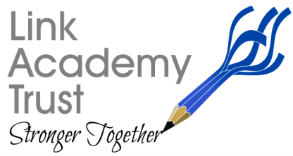
LINK ACADEMY TRUST
L a n d s c o v e S c h o o l H o u s e
L a n d s c o v e , Nr A s h b u r t o n
Devon. T Q 1 3 7 L Y
T e l : 0 1 8 0 3 7 6 2 1 1 3

Friday 12th June 2020
Dear parents and carers,

Remote Learning Parent Survey

Many thanks to all the parents who took the time to send us feedback on the online learning each school has been providing since we shut down at the end of March.
We will be using the results and most especially your comments to further improve the quality, quantity and appropriateness of the learning we provide into the future.

The results were as follows:

Q1 Are you finding the amount of work set:
Too little | 22 | 8%
The right amount | 206 | 70%
Too much | 65 | 22%

Q2 Is the level of challenge for your child:
Too easy | 35 | 12%
Just right | 227 | 77%
Too hard | 31 | 11%

Q3 Are you finding trying to teach your child:
Enjoyable | 27 | 9%
Stressful | 57 | 19%
Enjoyable at times/ stressful at times | 209 | 71%

Q4 How many children are learning from home in your household?
1 | 101 | 34%
2 | 146 | 50%
3 | 41 | 14%
4 | 5 | 2%
4+ | 0 | 0

Q5 On average how much time do you spend teaching each child in your family each day- i.e. working with them 1:1
1 hour per child | 131 | 45%
2 hours per child | 103 | 35%
3 hours per child | 41 | 14%
4 hours per child | 18 | 6%

We do realise just how difficult it is for you to manage the learning, often when many of you are also trying to work from home, so we intend to look into how we can make improvements and whether we can motivate children remotely more effectively. We are also looking into the possibility of providing some online learning for pupils over the summer break which will be optional.

We are intending to review the remainder of the term with regard to capacity and consider how we provide effective learning for all children across the Trust in the remaining weeks. This will include any actions that can improve online learning as well as the interactions with teaching staff.

We will continue to keep our schools as fully open as possible, obviously with due regard for the number of staff and the teaching space available in each school to ensure everyone’s safety. This is our paramount consideration.

The Link Academy Trust have endeavored to provide the best we can for pupils, opening as requested on 1st June for the designated year groups and key workers in all our schools, for the whole week. We will continue to provide these opportunities for as many children as we can going forward.

I would like to thank you all for your support and the positive attitude you have shown to our staff and schools. I will keep you all informed of actions that we will be taking and provision for September as soon as we have any further guidelines from the Government.

Have a super weekend, albeit a wet one I think!
Kind regards,
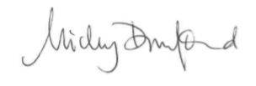
Nicky

