**Umbrella Narrative**

**HOOK:**

Learning about the weather in the Caribbean, creating a fact file about how the Caribbean compares to England.

Creating beach pictures.



English

Units: **Augustus and his smile**

We will start the term off by learning the story Augustus and his smile, we will adapt and change the story and make our own version.

**The Mousehole cat**

We will learn the story and look at how it focuses on stormy weather which links in with ‘wild weather’.

***Dippers Class***

***Wild Weather***

***Spring 2019***

Final event:

Story about wild weather

To explain local, significant events due to the weather

Phonics

Phase 5 sounds, including a_e, e_e, i_e.

**RE**

For the first part of the term we are learning about ‘belonging’, the children will also learn about Baptism and why it is important to Christians.

**Art**

The children will be focusing on ‘collage’ and creating their own rainbow pictures.

PE

PE will happen on Tuesdays and Thursdays this term, we will be learning how to play High 5 Netball and Handball.

*Wild Weather*

Maths

We will start by learning about mass and reading scales, we will also look at position. After that the children will be learning about time and addition and subtraction.



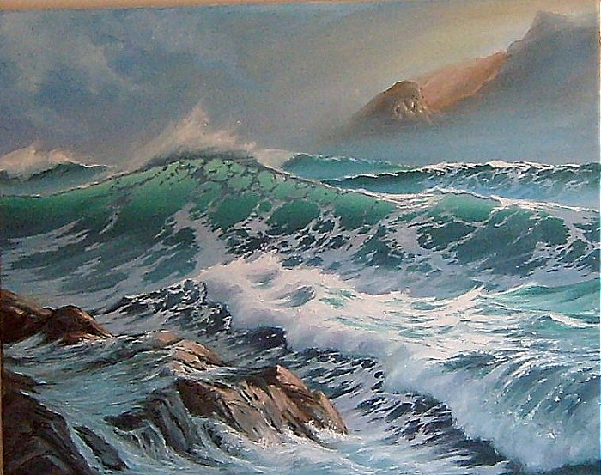

Geography-

We will start looking at ‘wild weather’ by identifying different weather patterns in the UK. The children will be learning how to use a map and we will then look at how ‘wild weather’ can affect what we can do.

Science –

Plants – over the first part of the term we will be focussing on ‘plants’ the children will planting bulbs and observing them as they grow.

Seasonal Changes – after half term we will be looking at the season ‘Spring’

Computing

Using Word and Excel to make bar charts and tables to record data.