 | 8:50 – 9:00 | 9:00 – 9:40 | 9:40 – 10:15 | 10:15 – 11;00 | 11:00 – 11:15 | 11:15 – 12:00 | 12:00 – 1:15 | 1:15 – 1:30 | 1:30 – 2:10 |  | 2:00 – 2:50 |  |  | 2:50 – 3:10 | 3:15
Monday | Wake and Shake | Phonics  Handwriting | Literacy | Maths  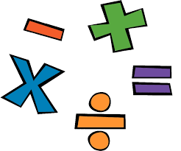 | Break | Guided Reading/Reading | Lunch | Afternoon activities | Art with KG & SS (PPA) |  |  |  |  | Collective Worship | Home Time
Tuesday |  | Phonics  Handwriting | Literacy | Maths |  | Guided Reading/Reading |  |  | 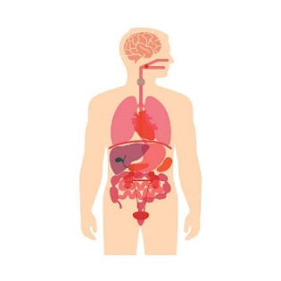  Science |  |  | PSHE | Collective Worship
Wednesday |  | Phonics  Handwriting | Literacy | Maths |  | Guided Reading/Reading |  |  | CW in Church |  | PE
Thursday |  | Phonics  Handwriting | Literacy | Maths |  | Guided Reading/Reading |  |  | Music | RE  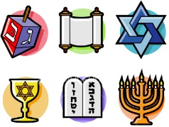 |  |  |  | Collective Worship
Friday |  | Forest School |  |  |  | Spellings  Homework |  |  | Independent Learning based around Topic |  |  |  |  | Achievers Assembly

