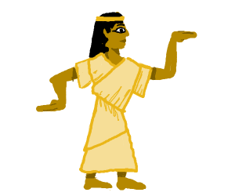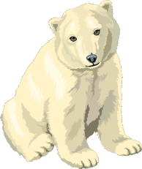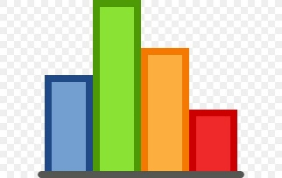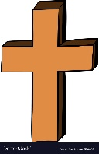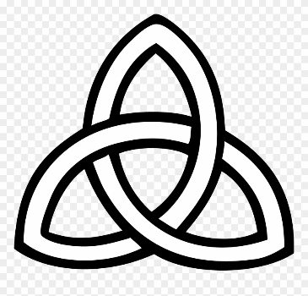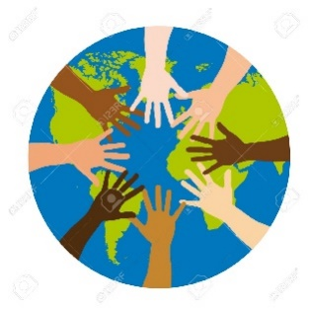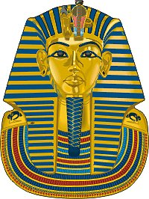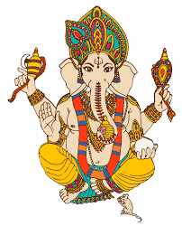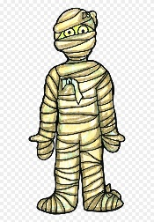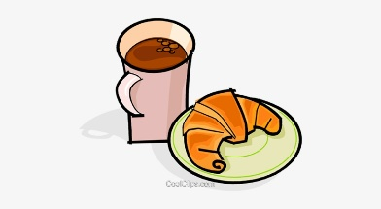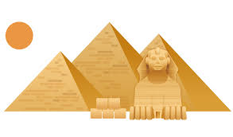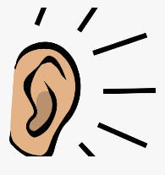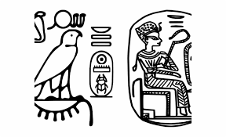

Walk like an Egyptian – Y4/5/6

**Maths:**

|  |  |
| --- | --- |
| Y4/5 | Y6 |
| Fractions and Decimals | Fractions and Decimals |
| Graphs | Graphs |
| Mass, Volume, Length | Measure and Volume |
| Time, Money | Percentages and Ratio |
| Area | Area |

**Computing:**

SCRATCH – Creating and developing games

**Religious Education:**

Why do Christians believe that Jesus is the Messiah?

**Science – VISITOR:**

**STEM Ambassador**

**Topic – History:**

Tutankhamun

Leaders and Rulers

**Hook:** Google Earth – Exploring modern day Egypt. Looking at the Pyramids on street view. Using Atlases and digital mapping.

**PSHE:**

**What is diversity?**

**What does discrimination mean?**

**Topic:**

Rituals and Beliefs

Mummification

**Religious Education:**

HINDUISM UNIT

What do Hindus believe God is like?

What does it mean to be a Hindu in Britain today?

Why do Hindus want to be good?

**P.E.:**

Hockey

**French:**

‘That’s Tasty’ – creating a restaurant menu

**P.E.:**

Dance

**P.E.:**

Volleyball

**Topic – Geography:**

The River Nile

The Great Pyramids

**Science – Sound – Experiments:**

String Cups

Instrument Testing

**P.E.:**

Handball

**Topic – Art/D&T:**

Mummifying Fruit

**Topic – Art/D&T:**

Mask Making

Pyramid Testing

**Science – Sound:**

How do we hear?

What does our ear look like?

**Science – Sound:**

Exploring pitch and volume

**Topic:**

Hieroglyphics

**Religious Education:**

What is the Trinity and why is it important for Christians?

**English:**

The Ice Bear (fiction)

Chitty Chitty Bang Bang and the race

against time (fiction)

Are humans damaging the atmosphere? (Non-fiction)

Earth Verse (poetry)