 Diptford C of E Primary School

*Diptford, Totnes*

*Devon*

*TQ9 7NY*

*Tel: 01548 821352*

*Email:* [admindiptford@thelink.devon.sch.uk](mailto:admindiptford@thelink.devon.sch.uk)

PROSPECTUS DOCUMENTS AND SCHOOL INFORMATION

A place of learning and discovery



Head Teacher Mrs L Lethbridge

**Admission Forms**

The following forms must be completed and returned before your child starts school with us:

1. Devon County Council Forms (2): Pupil Information S11/1 & Contact Information S11/2 and Disability Information (if applicable);
2. Consent form for Offsite Activities;
3. Consent form for Internet Use;
4. Consent form for Photography.
5. Home School Agreement
6. Privacy Notice

***When returning your admission forms please either provide a copy of your child’s birth certificate or bring us your original for us to check as we are required to certify your child’s date of birth*.**

**Information Sheets and other Forms**

There is always a lot to remember when starting school but we provide you copies of key documents that are also available to access at any time on or through the school website, *www.diptford.devon.sch.uk* should the paperwork get mislaid. We recommend you save the website address to your favourites.

1. Privacy Policy;
2. School Uniform Policy;
3. School Uniform Order Form;
4. FODS 100 Club Form;
5. Free School Meals information
6. School Lunch Meals Planner;
7. Holiday Dates for the current school year.

**General Information about our School**

**Our Early Years Unit:** Pre-school and Reception children share a space and form our early year’s unit. The environment is happy, active, exciting, fun and secure, with the Early Years Team supporting the development, care and learning needs of your child.

When children are due to start Reception in September, we normally have some school visits in the summer term (July). The Reception teacher will offer home visits and then during the first two weeks of school in September we have a gradual start.

**School Times:** The school bell rings at 8.50am and all children must arrive by this time. There is supervision in the playground from 8.40am so children can arrive after this time. We strongly encourage all children to be prompt and ready to start the school day at 8.50am. If you do arrive late then it is important to enter school via reception. Children will be marked late in the register if registration has finished (Registration closes at 9.00am). The number of late attendances is then recorded and noted on school reports. School finishes at 3.15pm and children can be picked up from the small playground/outside learning area outside Class 1 at this time. Access to the school at all other times must be via the School office to ensure the safety and security of our children.

**School Lunches:** The School Meal planner changes termly so the version enclosed may not be applicable for the term your child starts but it gives you an idea of the lovely meals cooked and provided by our school cook down in the Village Hall every day, currently charged at £2.50 per day. We are very lucky to still have our own cook providing hot nutritious meals for the children. Alternatively, you can provide your child with a packed lunch on any or all days.

If your child would like school meals it is very important that they are paid for **in advance,** at least weekly or monthly or half termly. Please put the cash or cheque (payable to Link Academy Trust) in an envelope marked with the pupil’s name, class and amount being paid. Your child’s lunch choices are taken a week at a time in advance and they can choose between Option 1, Option 2 (vegetarian) or Jacket Potato which is always available. From September 2014 all KS1 children will be entitled to free school meals automatically. If you have a child in KS2, they may also be entitled to free school lunches so please do consider this option to provide your child with a hot meal at lunchtime if your circumstances are applicable.

**After School Club:** The club is run by the Saints Southwest on Tuesday & Wednesday afternoons between 3.20pm and 5.30pm on the School’s premises. The emphasis is on play and we have a good range of resources as well as being able to tap into those based at the School.

Alongside the fun aspects of the club we encourage the development of team building and social skills. We welcome all school children regardless of age. The cost is £7.50 for a full session and £5.00 for a half session. Booking forms are available in the School office or for further information please come and have a chat with Rachael Vickers.

**Diptford School Website:** At *www.diptford.devon.sch.uk* the School website has a calendar for you to check what is coming up, photos of recent events, trips or visits and regular written updates from the Head Teacher. We recommend you check it regularly and at least weekly to stay up to date with what is happening in school. Each class also has its own page keeping you up to date with what has been going on and information about the curriculum that is being taught. The School terms dates, policies (like the homework policy), procedures and minutes of the School Committee meetings can be found here as well.

**PTA:** We have a very active parent’s association, called Friends of Diptford School or FODS for short. They also have their own website and request that parents (and or other interested parties like grandparents!) register their e-mail addresses on the website to receive e-mails about events taking place and school social matters. You will find their site at http://friendsofdiptfordschool.wordpress.com. You can do this at any time even before your child starts at Diptford School so that you can join in the community spirit. Alternatively, if you provide your email address on the forms enclosed FODS will do it for you.

FODS runs a lottery called the 100 club, which is a fundraiser and assists Diptford School in achieving its aims, like refurbishing the library and equipping Forest School, as well as providing the children with little extras at times, like Pantomimes and Discos! The 100 Club is open to anyone and members of the local community who can support the school. Information is included explaining how this operates and your support is appreciated.

**Other after school activities and clubs:** As well as the schools own After School Club, there are other clubs and activities some run by teachers, parents, volunteers or external instructors which the children can join if they wish. Examples of clubs that run are Football, Gardening Club, Netball, Recorder Club, and Tennis to name but a few. They do change frequently so it always worth asking in the School Office what clubs/activities are currently running.

**More help & advice**: We have a number of current Diptford parents who have kindly given their consent to be contacted by yourselves if you feel it would be useful and helpful to speak to them. They are more than happy to give you any help or advice with any queries or questions you may have regarding joining our school. Please contact the school office and Rachael will be able to provide you with their contact details.

**DIPTFORD CHURCH of**

**ENGLAND PRIMARY SCHOOL**

**PRIVACY NOTICE**

**Pupils in Schools and Early Years Settings**

**Data Protection Act 1998**

We at Diptford CofE Primary School are the Data Controller for the purposes of the Data Protection Act. We collect information from you and may receive information about you from your previous school and the Learning Records Service. We hold this personal data and use it to:

- support your child’s teaching and learning;

- monitor and report on your child’s progress;

- provide appropriate pastoral care; and

- assess how well the school is doing.

This information includes your contact details, national curriculum assessment results, attendance information (except for children in early years’ settings) and personal characteristics such as ethnic group, special educational needs and any relevant medical information.

***We will not give information about you or your child to anyone outside the school without your consent unless the law and our rules allow us to.***

We are required by law to pass some of your information to the Local Authority and the Department for Education (DfE). If you want to see a copy of the information we hold and share about you/your child then please contact the school administrator, Mrs Linda Pantry.

If you require more information about how the Local Authority (LA) and/or DfE store and use your information, then please go to the following websites:

www.education.gov.uk/schools/adminandfinance/schooladmin

If you are unable to access these websites, please contact the LA or DfE as follows:

Information Compliance Office

Information Management Teach

Devon County Council

Room L 10

County Hall

Exeter

EX2 4QX

Website: www.devon.gov.uk

Telephone: 0845 155 1015

Or:

Public Communications Unit

Department for Education

Sanctuary Buildings

Great Smith Street

London

SW1P 3BT

Website: www.education.gov.uk

**DIPTFORD CHURCH of ENGLAND PRIMARY SCHOOL**

**UNIFORM POLICY**

The wearing of school uniform is actively encouraged, fostering an identity with and pride in the school. Children should be encouraged to be clean, smart and presentable at all times.

Uniform embroidered with the school logo (detailed below) can be purchased from the Friends of Diptford School and order forms are available in the school office or on the school website. A selection of good quality second hand uniform is often also available (please speak to a member of the FODS committee with any requests). Pictures below are suggestions and are examples that can be found in the supermarkets or clothing stores that sell uniform. Non-logo items, such as trousers, shorts and summer dresses are readily available on-line if not in store.

**Girls are encouraged to wear:**

* Navy blue skirt or shorts/skorts or navy pinafore dress
* Smart blue trousers
* Royal blue and white checked dress in summer
* White blouse or polo shirt (available with the school logo embroidered)
* Navy sweatshirt with the school logo embroidered or navy cardigan
* Navy or white socks or navy tights
* Sensible and smart black shoes or sensible and smart black boots in the winter.

Light Blue Summer dress Tesco £7- £8.00

Navy Skirt

John Lewis £10

M&S Summer Dress £9-£10

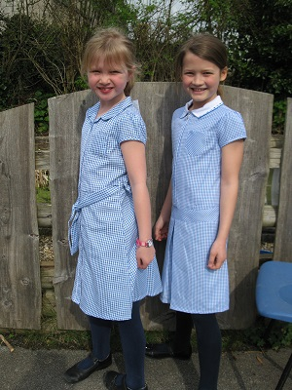 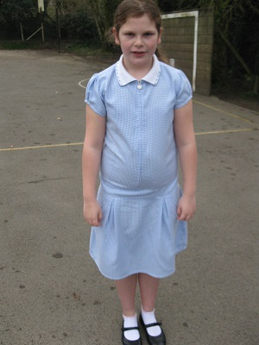 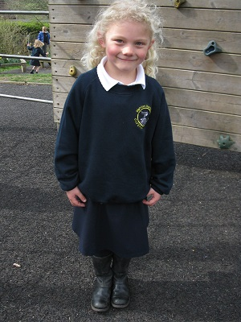

 

M&S 2 pack navy £8-£10

Tesco, Navy Trouser with Pleated Waistband £6

**Boys are encouraged to wear:**

* grey trousers or grey shorts
* White shirt or polo shirt (available with the school logo embroidered)
* Navy sweatshirt with the school logo embroidered
* Black, grey or white socks
* Sensible and smart black shoes

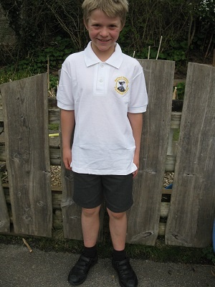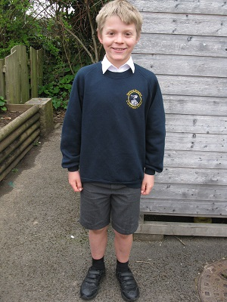 

Boys Winter

M&S 2 pk £8-£10

Boys Summer

M&S 2 pk Stain Resist £8-£10

**General Uniform Points:**

Trainers are not considered appropriate for school wear except for use in PE although they may change into them at playtimes.

The wearing of jeans, leggings and (except for use in games) jogging bottoms is not allowed.

Hats should be worn in the summer and sandals may be worn during this time but they should be of a sturdy variety and not a ‘flip flop’ type.

**COATS**

Please remember that your child walks from school to the village hall for lunch and as the weather is unpredictable having a waterproof jacket at school is often very useful. Fleeces are available with the school logo embroidered for chillier days but throughout the winter months your child will need to have a warm coat.

**PE KIT**

Children will need in school at all times the following PE kit:

Trainers (all children will require proper trainers rather than plimsolls)

* Navy shorts (cotton, jersey or football style)
* Pale blue polo shirt (available with the school logo embroidered)
* A named PE kit bag which can hang from a hook (a draw string bag is available with the school logo embroidered)
* A navy track suit or navy jogging bottoms would be useful for cold weather
* Gymnastics and Dance is done in bare feet.

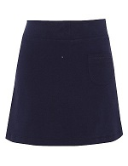 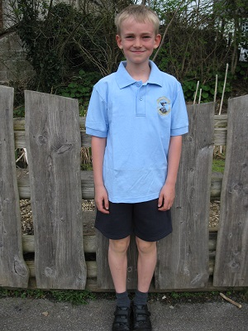

This is the PE Top (from School) and 100% cotton Shorts (M&S 2pk £6-£7)

95% Cotton Skort Navy, these are available at M&S (£6-£7)

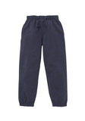 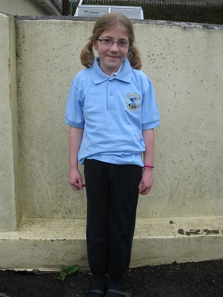

PE Top (from School) and M&S Jogger £5-£6

Navy jogging bottoms available from Tesco (£3-£4) and M&S (£5-£6)

**SCHOOL BAGS**

It is recommended that every child has a book bag. School navy book bags are available with the school logo embroidered and are on the order form. This protects reading books travelling to and from school and is also used to send any messages that need to be delivered in hard copy. Children should have a drinks bottle with a suitable drinking cap for the classroom. Only water will be allowed in the classroom.



**PLEASE ENSURE ALL ITEMS OF CLOTHING ARE CLEARLY MARKED WITH YOUR CHILD’S NAME**

Lost property will be returned to the owner if clearly marked, otherwise items are stored in a box.

**JEWELLERY**

No jewellery should generally be worn in school, with the exception of a wristwatch and, if ears are pierced small plain studs **only** which should be covered or removed for PE.

 Diptford C of E Primary School

*Diptford, Totnes*

*Devon*

*TQ9 7NY*

*Tel: 01548 821352*

*Email:* [admindiptford@thelink.devon.sch.uk](mailto:admindiptford@thelink.devon.sch.uk)

Dear Parents,

Please log on to:

https://oneonline.devon.gov.uk/CCSCitizenPortal_LIVE/Account/Login

Here you can apply for Free school meals.

Please do this even if you think you not eligible, this will ensure that your records are on the system and will mean that you will be able to **apply for school transfers, free transport and free school meals** as well as other applications whilst your child is in education

Kind regards   
  
Rachael Vickers   
Administrator

**Diptford Parochial C/E Primary School**

**School Uniform Order Form**

We hold a limited amount of school uniform in school it is from a different and more expensive   
supplier, albeit better quality.

So we hold emergency stock in School so that FODS money isn’t tied up in stock of uniform.   
Please be patient with us if we don’t immediately have your item in   
stock. We will generally order amounts in **July** (ready for the September intake), **January** and   
**April** so please see if you can plan your needs around these order times. Of course we all have   
emergencies and we might be able to assist with items from the “spares” cupboard if you need   
assistance until the order times. Many thanks – FODS

|  |  |  |  |
| --- | --- | --- | --- |
| Name of child : | | Class: | |
| Please Leave form in office – your order will be processed within ON **FRIDAY** AFTERNOONS…… | |  | |
| Item | Size  Please circle size required | Embroidered | Quantity required |
| Sweatshirts | 24, 26 28  30, 32  34, 36 | £8.75 |  |
| Cardigans | 24, 26 28  30, 32  34, 36 | £10.25 |  |
| Polo shirts – White  Polo Shirts - Pale Blue for PE | 22,24, 26, 28, 30, 32, 34, 36  22,24, 26, 28  30, 32, 34, 36 | £7.25  £7.25 | ---------- |
| Fleece | 3-4, 5-6 years  7-8, 9-10 years  11-12 years | £12.50 |  |
| Book Bag with logo  Swim/PE Bag with logo |  | £6.50  £4.50 |  |
| Total Amount enclosed: £ …………………...  If paying by cheque please make it payable to: FODS June 2018 | | | |

**Friends of Diptford School – 100 Club**

Charity Number: 1107047

The FODS 100 club was set up to generate funds for Diptford Primary School and is run by FODS. All proceeds are donated to the school, with the only costs being the monthly draw prizes and the costs of the annual licence. The draw is run in accordance with lottery regulations under the licence issued by South Hams District Council.

Each month a draw is held from a maximum of 100 balls. Three balls are drawn out (1st prize £50, 2nd prize £25 and 3rd prize £10). Approximately 50% of the monthly draw income is distributed in prizes, the balance being retained by FODS for donation to the school.

To become a member of the 100 Club and join the monthly draw you need to purchase one or more balls. The cost for one ball for a year (12 draws) is £60, equivalent to £5 per month. This can be paid for by a monthly standing order or a one-off payment.

You can join at any point in the year. You do not have to have children at the school to participate – friends, family and members of the local community are also welcome.

One ball costs £60 per annum, two balls £120 and three balls £180.

**HOW TO PAY:**

**Cheque:** If you wish to pay by cheque please enclose when you return this form.

**BACS or Standing Order:** If you wish to pay by BACS or Standing Order please use the bank details below. This can either be done in branch or by internet banking. IF PAYING BY MONTHLY STANDING ORDER PLEASE ENSURE THAT THE PAYMENT WILL ARRIVE IN THE FODS ACCOUNT BETWEEN 1st AND 5th OF EACH MONTH.

**Account:** Friends of Diptford School, Lloyds TSB, 31 Fore Street, Totnes, Devon TQ9 5HH

Sort code: 30-98-69 Account no: 0108649

Please return the form below to FODS. Details of FODS committee members can be found on the FODS website (http://friendsofdiptfordschool.wordpress.com) together with the monthly winners.

**Friends of Diptford School 100 Club**

**Name: ................................................................(**block capitals please).

**Address: ……………………………………………………………………………………………………………………….**

**Telephone: .....................................................................**

**Email: ..........................................................................**

**I am paying by Cheque BACS (one payment) Monthly Standing Order**

**For balls for: Months / Year / Until further notice (circle as appropriate).**

**Signed: .............................................................................**

***Holiday Dates Autumn 2018 – Summer 2019***

***Autumn Term 2018***

*Term commences     -    Wednesday 5th September, 2018*

*Half term               -     Monday 22nd October – Friday 26th October 2018*

*Term ends              -      Thursday 20th December, 2018*

***Spring Term 2019***

*Term commences     -     Tuesday 8th January, 2019*

*Half term                  -     Monday 18th February – Friday 22nd February, 2019*

*Term Ends                -     Friday 5th April, 2019*

***Summer Term 2019***

*Term commences    -      Wednesday 24th April, 2019*

*May Bank Holiday  -       Monday 6th May, 2019*

*Half term               -        Monday 27th May – Friday 31st May, 2019*

*Term ends             -        Tuesday 23rd July, 2019*

***Non pupil days (5)***

*Monday 3rd September, 2018*

*Tuesday 4th September, 2018*

*Friday 21st December, 2018*

*Monday 7th January, 2019*

*Tuesday 23rd April, 2019*

***Occasional Days***

*Wednesday 24th July, 2019*

*Thursday 25th July, 2019*

***Holiday Dates Autumn 2019 – Summer 2020***

***Autumn Term 2019***

*Term commences     -    Wednesday 4th September, 2019*

*Half term               -     Monday 21st October – Friday 25th October 2019*

*Term ends              -      Thursday 19th December, 2019*

***Spring Term 2020***

*Term commences     -     Tuesday 7th January, 2020*

*Half term                  -     Monday 17th February – Friday 21st February, 2020*

*Term Ends                -     Friday 27th March, 2020*

***Summer Term 2020***

*Term commences    -      Wednesday 15th April, 2020*

*May Bank Holiday  -       Monday 4th May, 2020*

*Half term               -        Monday 25th May – Friday 29st May, 2020*

*Term ends             -        Tuesday 21st July, 2020*

***Non pupil days (5)***

*Monday 2nd September, 2019*

*Tuesday 3rd September, 2019*

*Friday 20th December, 2019*

*Monday 6th January, 2020*

*Tuesday 14rd April, 2020*

***Occasional Days***

*Wednesday 22nd July, 2020*

*Thursday 23rd July, 2020*